**Department of Electrical Engineering and   
Computer Science**

**Faculty Member:** Dr. Huma Ghafoor  **Dated:** 9/02/2023

**Semester:** 6th **Section:** BEE 12C

**EE-351 Communication Systems**

Lab 2: Balanced Modulator

Group Members

|  |  |  |  |  |  |  |
| --- | --- | --- | --- | --- | --- | --- |
| **Name** | **Reg. No** | **Viva / Quiz / Lab Performance** | **Teamwork** | **Ethics** | **Software Tool Usage** | **Analysis of data in Lab Report** |
|  |  | **5 Marks** | **5 Marks** | **5 Marks** | **5 Marks** | **5 Marks** |
| Muhammad Ali Farooq | 331878 |  |  |  |  |  |
| Danial Ahmad | 331388 |  |  |  |  |  |
| Muhammad Umer | 345834 |  |  |  |  |  |
| Tariq Umar | 334943 |  |  |  |  |  |

**Table of Contents**

3 Balanced Modulator 3

3.1 Objectives 3

3.2 Introduction 3

3.3 Lab Report Instructions 3

4 Lab Procedure 4

5 Conclusion 11

**Table of Figures**

Figure 1: AM Output 4

Figure 2: AM Output with Scale Change 5

Figure 3: Less than 100% AM Output 5

Figure 4: Frequency Spectra of the AM Output 6

Figure 5: SSB Modulated Output 8

Figure 6: Variation in Modulation % with Amplitude of Message Signal 8

Figure 7: MIXER's Carrier Signal 9

Figure 8: MIXER’s Output 9

# Balanced Modulator

## Objectives

When you have completed this lab exercise on the balanced modulator, you will be able to

* Describe the circuit block
* Explain the output signal’s relationship to the two input signals
* Describe the operation and applications

## Introduction

The balanced modulator is a widely used circuit in various fields, especially in communication systems. Its ability to perform amplitude modulation of an input signal using another input signal has made it an essential component in radio and television broadcasting, telecommunication, and other related areas. The objective of this lab report is to explore the functionality and operation of a balanced modulator.

Understanding the balanced modulator is crucial for communication engineers, especially those working on analog modulation techniques. This report will provide an in-depth analysis of the circuit and its characteristics.

## Lab Report Instructions

All questions should be answered precisely to get maximum credit. Lab report must ensure following items:

* Lab objective
* Results (screen shots) duly commented and discussed.
* Conclusion

# Lab Procedure

1. Locate an AM/SSB transmitter circuit block on the Analog Communications Circuit and connect the Signal Generator to the M of Modulator. Set Switches S1, S2 and S3 to OFF.

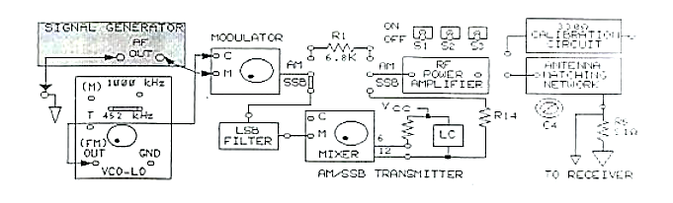

1. Turn the negative supply knob on the left side of the base unit fully CCW to adjust the VCO-LO frequency to less than 452kHz.
2. Connect the oscilloscope of channel 1 probe to the message signal input M to the modulator. While observing the signal on channel 1, adjust the SIGNAL GENERATOR for a 300mVpk-pk, 3kHz sin wave at M.
3. Connect the oscilloscope channel 2 probe to the carrier signal input C on the modulator. While observing the signal on channel 2, adjust the amplitude knob on VCO-LO for 100mVpk-pk at C.
4. Connect the oscilloscope channel 2 probe to the modulator’s output.

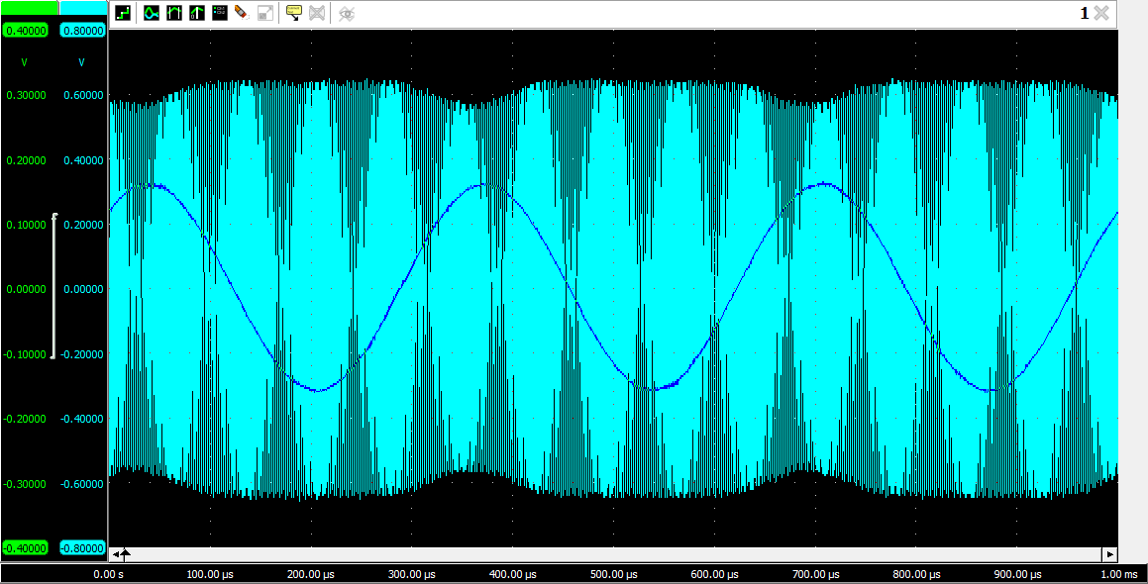

Figure : AM Output

1. Set the oscilloscope vertical mode to channel 2, and trigger in channel 1. Set the channel 2 attenuation to 500mV/DIV and set the oscilloscope sweep to 0.1ms/DIV.

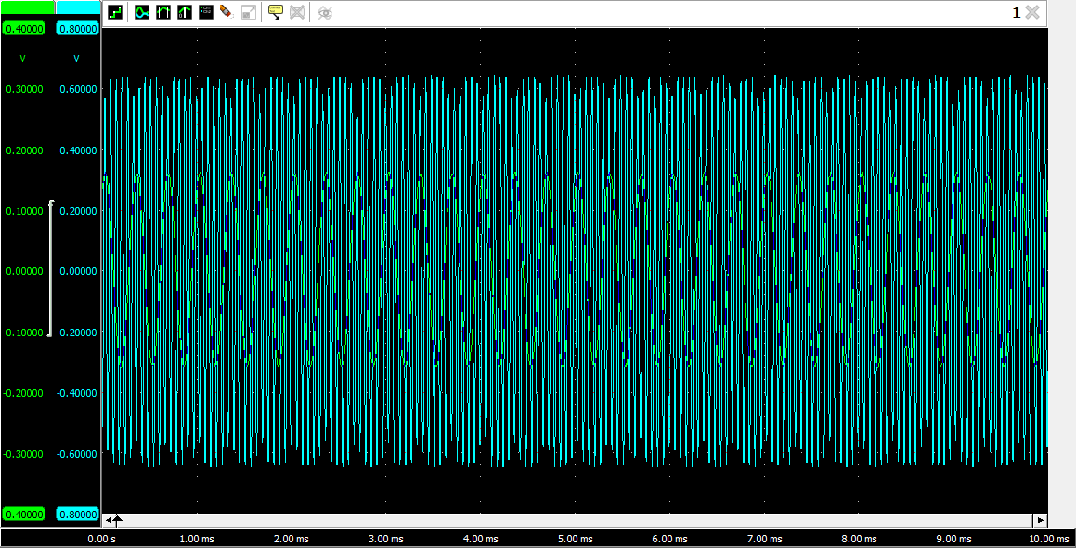

Figure : AM Output with Scale Change

1. Turn the modulator’s potentiometer knob fully CCW and then slowly turn it CW until the AM signal is less than 100% modulated.

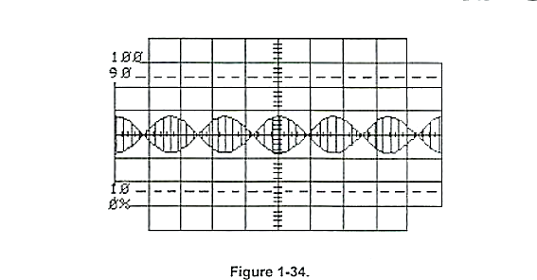

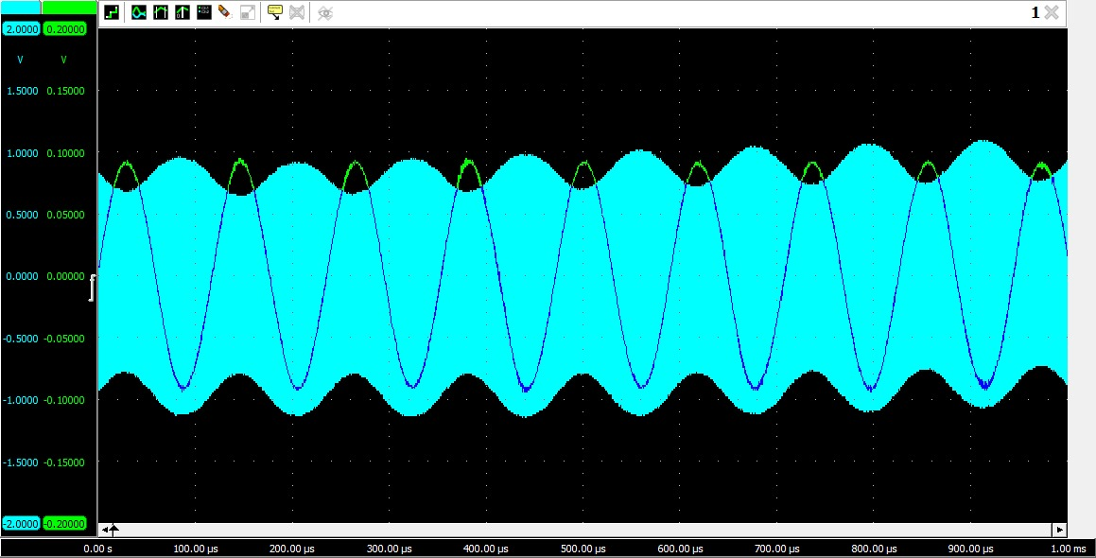

Figure : Less than 100% AM Output

1. Continue to turn the knob slowly CW until the AM signal appears as shown in Figure 1-35. What type of AM modulated signal appears on channel 2: SSB, DSB, or 100% modulated?

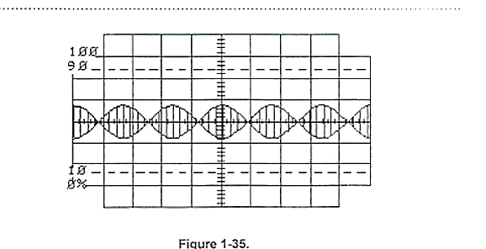

**Answer:** The returning AM output is DSB and 100% modulated, apparent from the absence of phase reversal phenomenon and B = 0.

1. If the carrier frequency signal is 452kHz and the message signal frequency is 3kHz, what frequencies would be present in the frequency spectrum of the DSB signal?

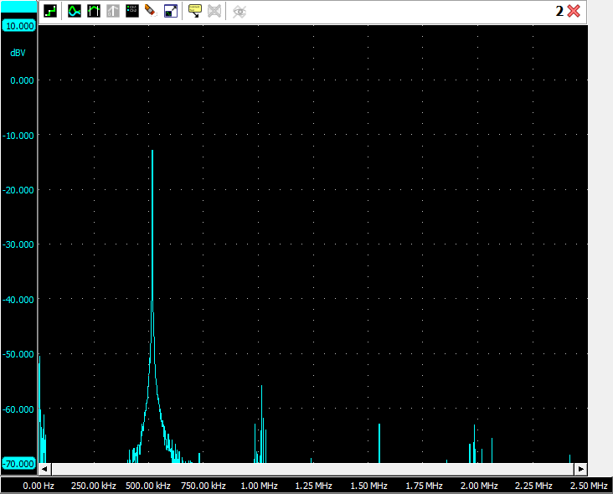

Figure : Frequency Spectra of the AM Output

**Answer:** In Double-Sideband (DSB) modulation, the frequency spectrum of the modulated signal contains the sum and difference frequencies of the carrier frequency and the message signal.

Therefore, the frequencies present in the frequency spectrum of the DSB signal are:

* Carrier frequency: 452 kHz
* Upper sideband frequency: 452 kHz + 3 kHz = 455 kHz
* Lower sideband frequency: 452 kHz - 3 kHz = 449 kHz

1. The LSB FILTER is a narrow-band bandpass filter that passes frequencies between 453kHZ and 457kHz. Any frequencies not in this range are filtered.

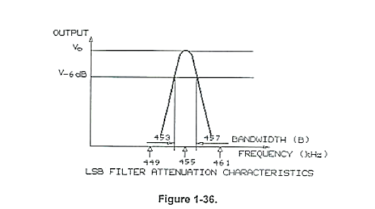

1. Connect the oscilloscope channel 2 probe to the output of LSB FILTER. Set the oscilloscope vertical mode to channel 2, trigger on channel 2, set the channel 2 attenuation to 50mV/DIV and set the sweep to 1us/DIV.

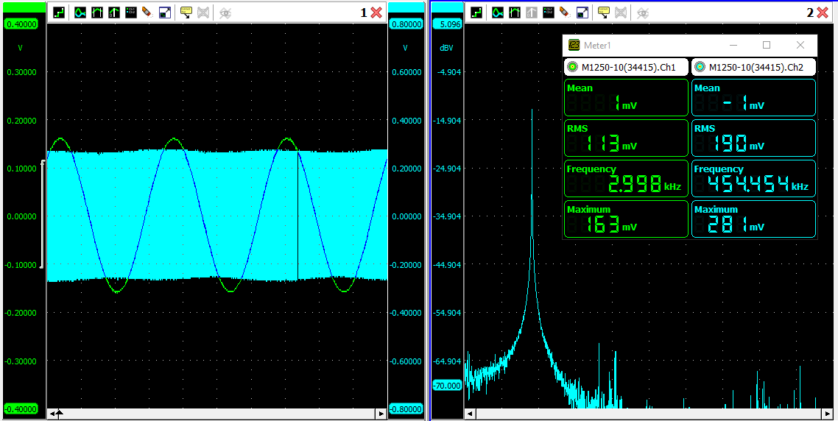

1. Increase the VCO-LO’s frequency to the modulators by slowly turning the negative suppl knob CW until the LSB FILTERS output signal is maximum.
2. What is the LSB FILTERS output signal shown on channel 2: a greater than 100% modulated signal, DSB signal or an SSB signal.

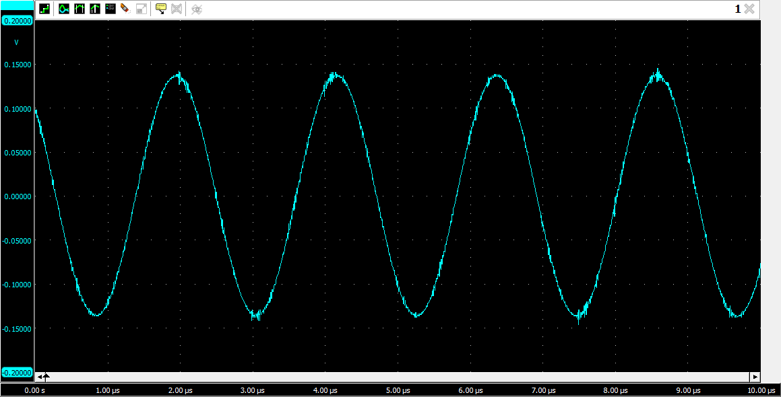

Figure : SSB Modulated Output

**Answer:** After passing the AM output through the LSB filter, the resulting waveform obtained is SSB (Single sideband) modulated.

1. While observing the 455kHz signal at the LSB filters output on the channel 2, vary amplitude of the 3kHz message signal to the modulator by varying AF LEVEL knob on the SIGNAL GENERATOR. Does the amplitude of the 455kHz signal vary with the amplitude of 3kHz message signal.

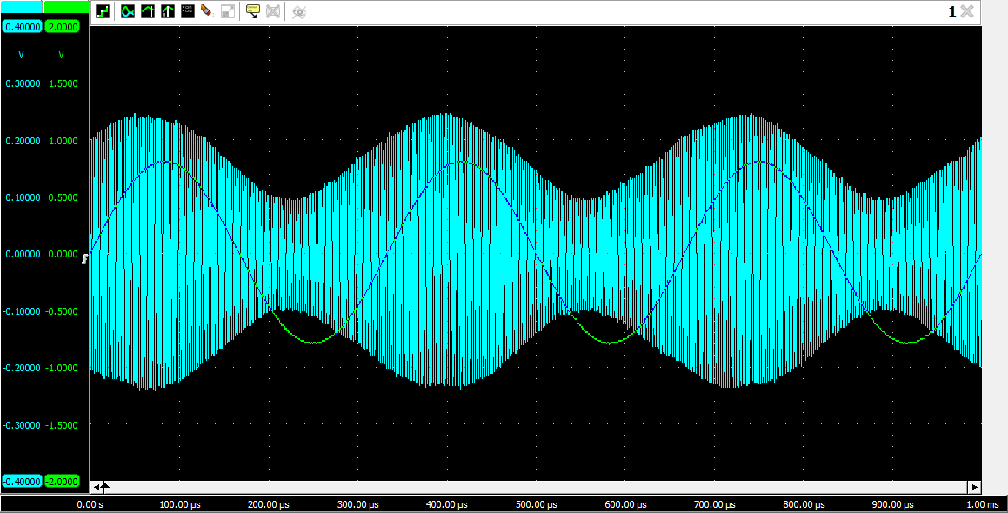

Figure : Variation in Modulation % with Amplitude of Message Signal

**Answer:** Yes, the carrier signal changes according to the amplitude of the message signal in Amplitude Modulation.

1. Connect the output of the VCO-HI circuit block to the input of C at the mixer. In the following steps you will observe how a balanced modulator functions as a MIXER to increase the frequency of a signal.
2. Turn the POSITIVE SUPPLY knob on the right side of the base unit fully CCW to set the VCO-HI frequency above 1455kHz.
3. Set the oscilloscope sweep to 05us/DIV. Connect the channel 2 probe to the MIXER’s C input. Adjust the VCO-HI oscillator signal 100mVpk-pk with the potentiometer knob on the VCO-HI circuit block.

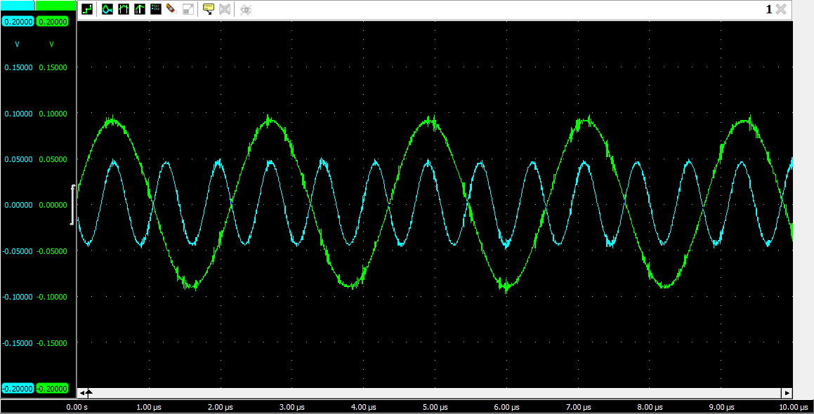

Figure : MIXER's Carrier Signal

1. Connect the channel 1 to the LSB filter output and trigger on channel 1. Connect channel 2 to pin 6 at the MIXER’S output. Set channel 2 to 200mv/DIV.

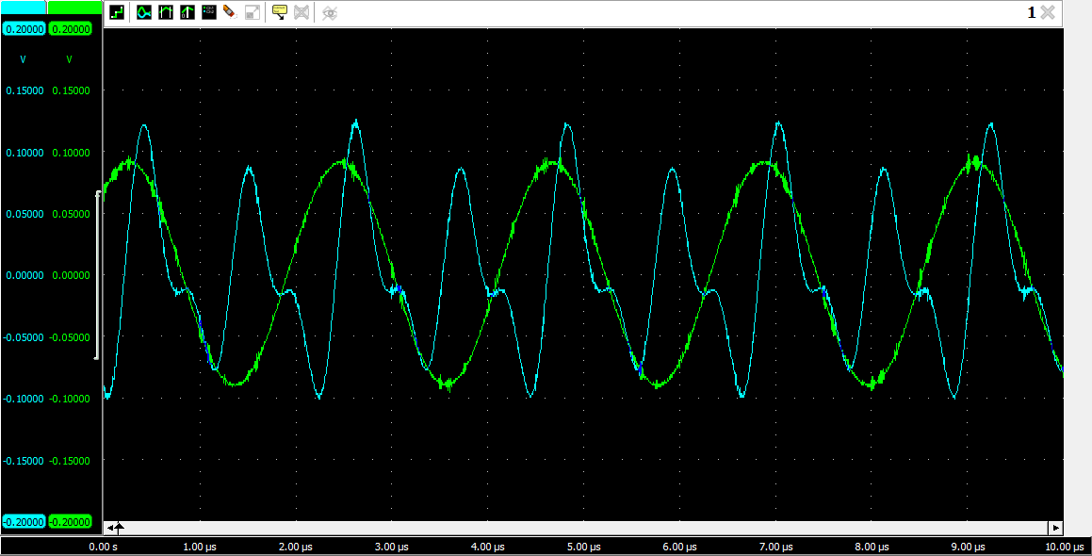

Figure : MIXER’s Output

1. Adjust the MIXER’s potentiometer knob for a DSB signal at pin 6.

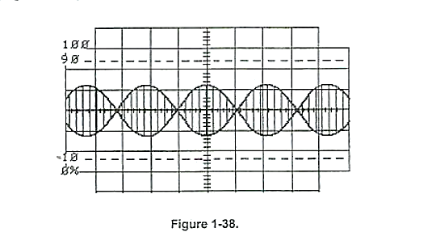

1. Set the channel 2 to 500 mv/DIV and then trigger on the channel 2. Connect channel 2 to pin 12 at the mixer, which is the LC filters output. The signal should appear as a trace.
2. Adjust the VCO-HI frequency to 1455khz by slowly turning the POSITIVE SUPPLY knob CW until the SSB signal at pin 12 of the MIXER is maximum.

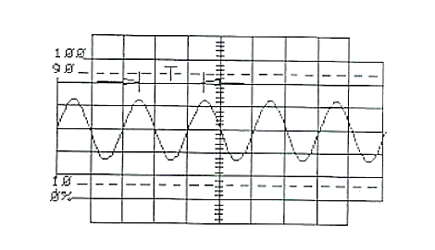

1. Measure the period (T) between peaks of the waveform. Each horizontal division is 0.5us.

**Answer:** From the output figure, the time period between the peaks is obtained to be $T=2.34 μs.$

1. From the period (T), calculate the frequency of the SSB at pin 12 of the MIXER.

**Answer:** As time and frequency are inversely related, $f = 1/T = 427350.42 Hz$

1. While observing the 1000khz signal at the LC FILTER’S output, vary the amplitude of the 3khz message signal to the modulator by varying the AF LEVEL knob on the SIGNAL GENERATOR. Does the amplitude of the 1000kHz signal at pin 12 vary with the amplitude of the 3kHz message signal?

**Answer:** Yes, the amplitude of the modulated signal varies with a change in the amplitude of the message signal. In fact, this is one of the key characteristics of modulation. This relation is also apparent from the equation:

$$x\left(t\right)=\left(1+k_{A}m\left(t\right)\right).cos⁡(2πF_{c}t)$$

# Conclusion

In conclusion, the balanced modulator is an essential circuit for amplitude modulation of an input signal using another input signal. Through this lab exercise, we have explored the circuit's basic components and its functionality, along with its applications and limitations. We have learned that the balanced modulator is a critical component in various communication systems, including radio and television broadcasting, telecommunication, and many more. Its ability to perform modulation while suppressing the carrier signal has made it an efficient technique for analog communication. Additionally, we have explained the relationship between the output signal and the two input signals, and we have described how the balanced modulator circuit works.